**SUBJECTIVE PART (40 Marks)**

**Question No 02: Errors identification. (Total Marks: 14)**

1. **[4 Marks]**

Which of the following array definitions are invalid, and why? If a line does not contain error, clearly state “NO ERROR!”.

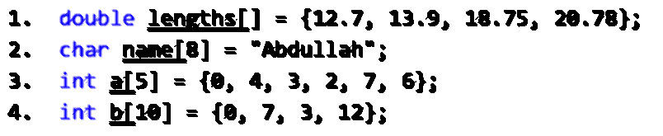

1. **[5 Marks]**

Given the declaration:

char string15[16];

Identify which of the following statements have COMPILE-TIME error. If a statement has an error, describe (in a single line) why? If a line does not contain error, clearly state “NO ERROR!”.

1. **[5 marks]**

Consider the following variables declaration.

int x=10, y=20, z=50;

double d=3.14;

Identify and state the problems (compile-time/run-time errors) with each of the following lines of code, if any. If a line does not contain error, clearly state “NO ERROR!”.

**Question No 03: Debug Errors. (Total Marks: 05)**

1. **[3 Marks]**

Identify the error with the following code and rewrite after correcting it.

1. **[2 Marks]**

Assuming we want to input 5 values in an array ‘a’, rewrite the following code after correcting it:

**Question No 04: Short questions/code snippets. (Total Marks: 15)**

1. **[2 Marks]**

Explain the difference between a value and a reference parameter.

1. **[2 Marks]**

Write down a statement, which defines an array of C-style strings and stores the names of four seasons in it using the array initializer syntax (i.e. initialize the array at the time of its declaration).

1. **[5 Marks]**

Write down a code script to open a file (data.txt) in append mode. Then, validate the file-opening operation. If the file is successfully opened, the write an integer new_employee_id value (input from user) to the file and close the file.

1. **[6 Marks]**

Consider the following struct definition:

struct employee_t

{

    int empid, grade; // grade can be within [1-20], e.g. 19

    string name; // e.g. Muhammad Ali

    date_t joiningdate;

    address_t homeaddress;

    float workhours[7]; // how many hours the employee worked on each day of week, e.g. {4.5, 5, 6, 5.5, 8, 7, 0}

};

struct date_t

{

    int year, month, day; // e.g. 1986, 2, 12

};

struct address_t

{

    string city_name; // E.g. Lahore

    town_t town;

};

struct town_t

{

    string townname; // e.g. Punjab Society

int housenumber;  // e.g. 42

    char sectorcode;  // e.g. B

};

Consider the struct definitions given above. Assume that we have an array of 3 employees, which is already initialized with some sample data. You have to write down a loop, which prints the data of all the employees in a descriptive form. For your reference, the data of a single employee should be printed in the descriptive form as follows.

Employee **Muhammad Ali** (ID: **786**) has grade **19**. He joined the company since **23-06-1984**, and is located currently at **42**-**B**, **Punjab Society**, **Lahore**. His work hours during the last week were **36**.

**Question No 05: Program output. (Total Marks: 06)**

1. **[6 Marks]**

What is the output of the following program?

